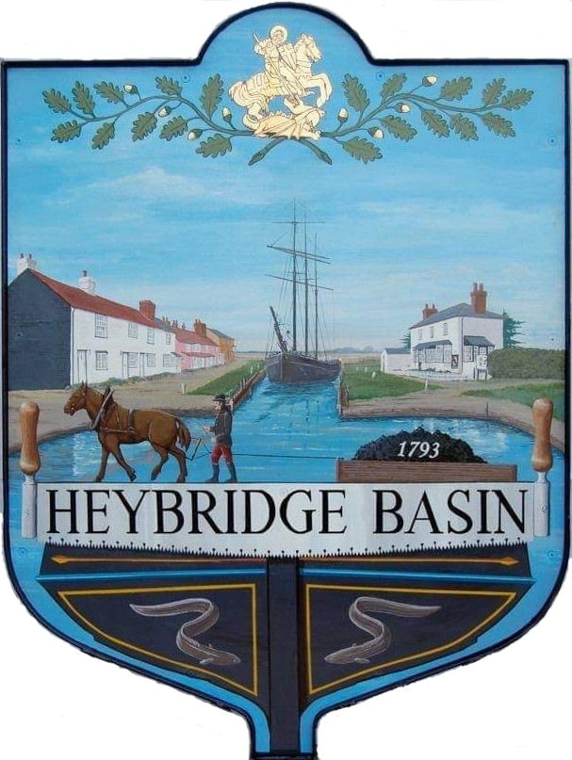

HEYBRIDGE BASIN PARISH COUNCIL

Minutes of the Annual Parish Assembly of Heybridge Basin held on Tuesday 23rd April 2024 at 06.00pm, at The Lock Tearoom.

PRESENT

In the Chair: M. Hodges (Chair) Absent: 0

Councillors: R. Bryson (Vice Chair) Apologies: 1 M. Hobden
J. Sjollema Public: 7
C. Swann
C. Edmond District Cllrs: N. Spenceley
N. Swindle

County Cllrs: M. Durham Officers: G. Lake – Clerk

It was noted that this meeting was being recorded by the Clerk.

23/230 Chair’s Welcome: Cllr Hodges
The Chair welcomed everyone to the meeting.

23/231 Apologies for Absence.
Cllr Howat

23/232 To approve the Minutes of the Annual Parish Meeting held on Tuesday 16th May 2023
The Minutes as previously circulated were agreed as a correct record.

23/233 Chair’s annual report: Cllr Hodges
The Chair read his report.

23/234 County Councillors annual report: Cllr Durham
Cllr Durham read his report and informed the Council that the Local Highways Panel (LHP) were re-discussing the application for village Gateways as new sizes had become available.

23/235 District Councillors annual report: Cllrs Spenceley and Swindle
Cllr Spenceley read his report.

23/236 Reports from local community groups and organisations:
- Heybridge Basin Conservation Society – Doug Milsted
- Heybridge Basin Sailing Association – Marion Hoben
- Keep Britain Tidy – Richard Holland
- Friends of St Georges – Paula Abbot
- Stitch, Knit and Natter – Paula Abbot
- Row 4 a Reason – Chris Oatham
- Neighbourhood Watch - Absent
- Community Speed watch Group – Bill Riches
- Essex Waterways – Colin Edmond
- Regatta Committee – Marie Ellis
Representatives from each group read a report. Cllr Bryson read a report on behalf of Marie Ellis.

23/237 Open Forum for the public to raise any matters of interest.
A member of the public (MOP) raised concerns over the overgrown vegetation along the footpath past The Jolly Sailor – The Chair advised that this was not the responsibility of the PC, however the Clerk would investigate whose responsibility it was.

Two MOP’s raised concerns regarding the on-street parking within the village, and questioned what enforcement was being taken. The Chair advised that the on-street parking petition for the South East Parking Partnership (SEPP) required more responses, and that this was going to be actioned as soon as possible.

23/238 Close
The Chair thanked Councillors and members of the public for attending.

There being no further business the meeting closed at 07:30pm
Provisional Date of the next Council Meeting Monday 20th May 2024

Clerk Contact details: clerk@heybridgebasinpc.org.uk
Website: www.heybridgebasin-pc.gov.uk

